The National Alliance for Caregiving (NAC) and the Act on RAISE Campaign developed this toolkit to equip caregivers and partner organizations with resources to advocate for the reauthorization of the Older Americans Act (OAA).

The OAA is at a pivotal moment. Its authorization expired in 2024. While programs continue to receive funding, they lack the updates, funding growth, and long-term stability that come only through reauthorization.

This toolkit is designed to help you take action. Inside, you’ll find:
- Key talking points explaining more about the OAA, its impact and support of family caregivers, and why it must be reauthorized.
- Policy and educational resources including links to fact sheets on the OAA and the National Family Caregiver Support Program (NFCSP).
- Template social media posts and graphics to share with your networks.
- A template Letter to the Editor to raise awareness in your community.

Together, we can raise the voices of America’s 63 million family caregivers and ensure Congress understands the essential role OAA programs play in supporting families and strengthening communities. Thank you.

If you have any questions, please feel free to reach out to Davisha Davis at Davisha@caregiving.org.

Talking Points

Introduction: Why This Matters
For nearly 60 years, the Older Americans Act (OAA) has been the cornerstone of our nation’s commitment to helping older adults age with dignity and supporting the family caregivers who make that possible. Through programs that provide nutrition assistance, home-delivered and congregate meals, transportation services, caregiver support, disease prevention services, long-term care, and more, the OAA touches millions of lives every year.
- Today, the need for these programs is clear. Each day, on average, 10,000 Americans turn 65. Older adults are living longer with more complex health challenges. At some point, 70% of them will need some type of long-term care.
- The number of family caregivers has grown dramatically – with a 45% surge from 2015 to 2025, going from 43 million to 63 million family caregivers in just 10 years.
- Reauthorizing the OAA in 2025 is an opportunity for Congress to update and strengthen a proven law, so that it meets the realities of an aging population and the families who care for them.

Current Bill Status: Where Things Stand
Senate Bill S. 2120: Older Americans Act Reauthorization Act of 2025 was introduced on June 18, 2025, with bipartisan support and is pending in the Senate HELP Committee. The bill would extend OAA programs through FY 2030, strengthen caregiver support and direct care workers, and expand protections for Tribal and rural communities. The House has not yet advanced a companion measure.

Authorization for the OAA expired at the end of FY 2024. Congress initially included an extension in the FY 2025 continuing resolution (CR), but that language was removed from the final bill—leaving the OAA without authorization. Programs are still funded through appropriations, but they lack updated policy direction and long-term certainty. In 2024, the Senate unanimously passed a bipartisan reauthorization bill, but the House failed to act before expiration.

There are no significant changes included in the 2025 Senate reauthorization from the proposed version in 2024.

The Caregiving Reality in 2025
According to Caregiving in the US 2025, a new report from the National Allaince for Caregiving and AARP:
- 63 million Americans are family caregivers—nearly 1 in 4 adults, a nearly 50% increase since 2015.
- 24% provide 40+ hours/week of unpaid care, equal to a full-time job.
- Nearly half report financial strain, while 1 in 5 rate their health as fair or poor.
- Only 11% receive formal training, despite providing complex medical and daily living support.
- A growing share are “sandwich generation” caregivers, caring for both children and older adults.

Why OAA Reauthorization Matters Now
- The OAA funds services like Meals on Wheels, transportation, caregiver respite, and elder justice protections, services that allow older adults to remain at home.
- The National Family Caregiver Support Program (NFCSP) within the OAA delivers respite, counseling, and training; however, resources remain far below demand.
- Reauthorization ensures the OAA continues to anchor the National Strategy to Support Family Caregivers and adapt to today’s caregiving landscape.

What’s at Stake Without Action
- Older adults risk losing services that prevent isolation and institutionalization.
- Caregivers could lose access to respite and training, increasing financial strain and burnout.
- States and Medicaid may face higher costs if more older adults must enter institutional care instead of aging at home.

Asks of Congress
- Reauthorize the OAA in 2025 without delay.
- Provide multi-year funding through FY 2030, as outlined in S. 2120.
- Expand caregiver support programs, including respite, counseling, and training.
- Invest in the direct care workforce to stabilize home- and community-based services.

Call to Action
The OAA has always been a bipartisan commitment to older Americans and their families. With millions of caregivers providing unpaid care, reauthorization is both timely and necessary. Congress must act in 2025 to reauthorize and strengthen the OAA so that older adults can age with dignity and caregivers have the support they need to continue in their vital role.

Policy & Educational Resources

National Family Caregiver Support Program  Fact Sheet | Older Americans Act  Fact Sheet
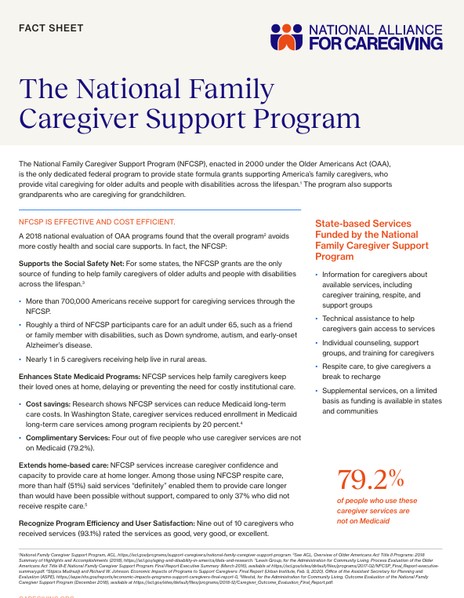 | 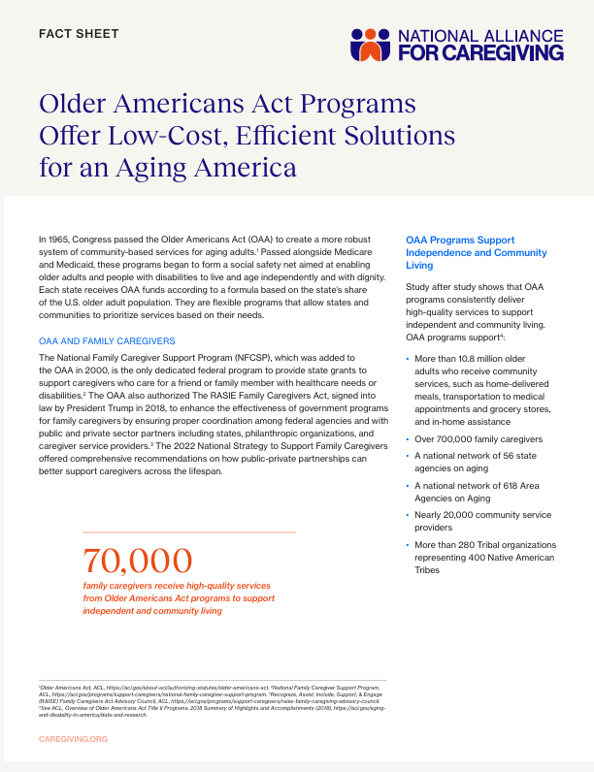

Additional Resources
AARP and National Alliance for Caregiving. (2025, July 24). Caregiving in the US 2025. Washington, DC: AARP. https://doi.org/10.26419/ppi.00373.001

Bangerter, L. R. (2019). The Older Americans Act and Family Caregiving: Perspectives from Federal and State Levels . Public Policy & Aging Report, 29(2), 62–66.

National Alliance for Caregiving. (2024) Older Americans Act Reauthorization Policy Brief. National Alliance for Caregiving.

Senate HELP Committee. (2025, June 18). Chair Cassidy, Ranking Member Sanders, Colleagues Reintroduce Older Americans Act to Empower American Seniors [Press release].

USAging. (2024). Older Americans Act Factsheet. USAging.

Four Congressional Research Service Documents:
- CRS: Older Americans Act -- 2020 Reauthorization (July 2020)
- CRS: Older Americans Act-- Summary in Brief (May 2024)
- CRS: Older Americans Act -- Overview and Funding (May 2024)
- CRS: Older Americans Act – 2025 Reauthorization (2025)

Template Social Media Graphics & Posts

Sample Graphics
Click here to Download Graphics
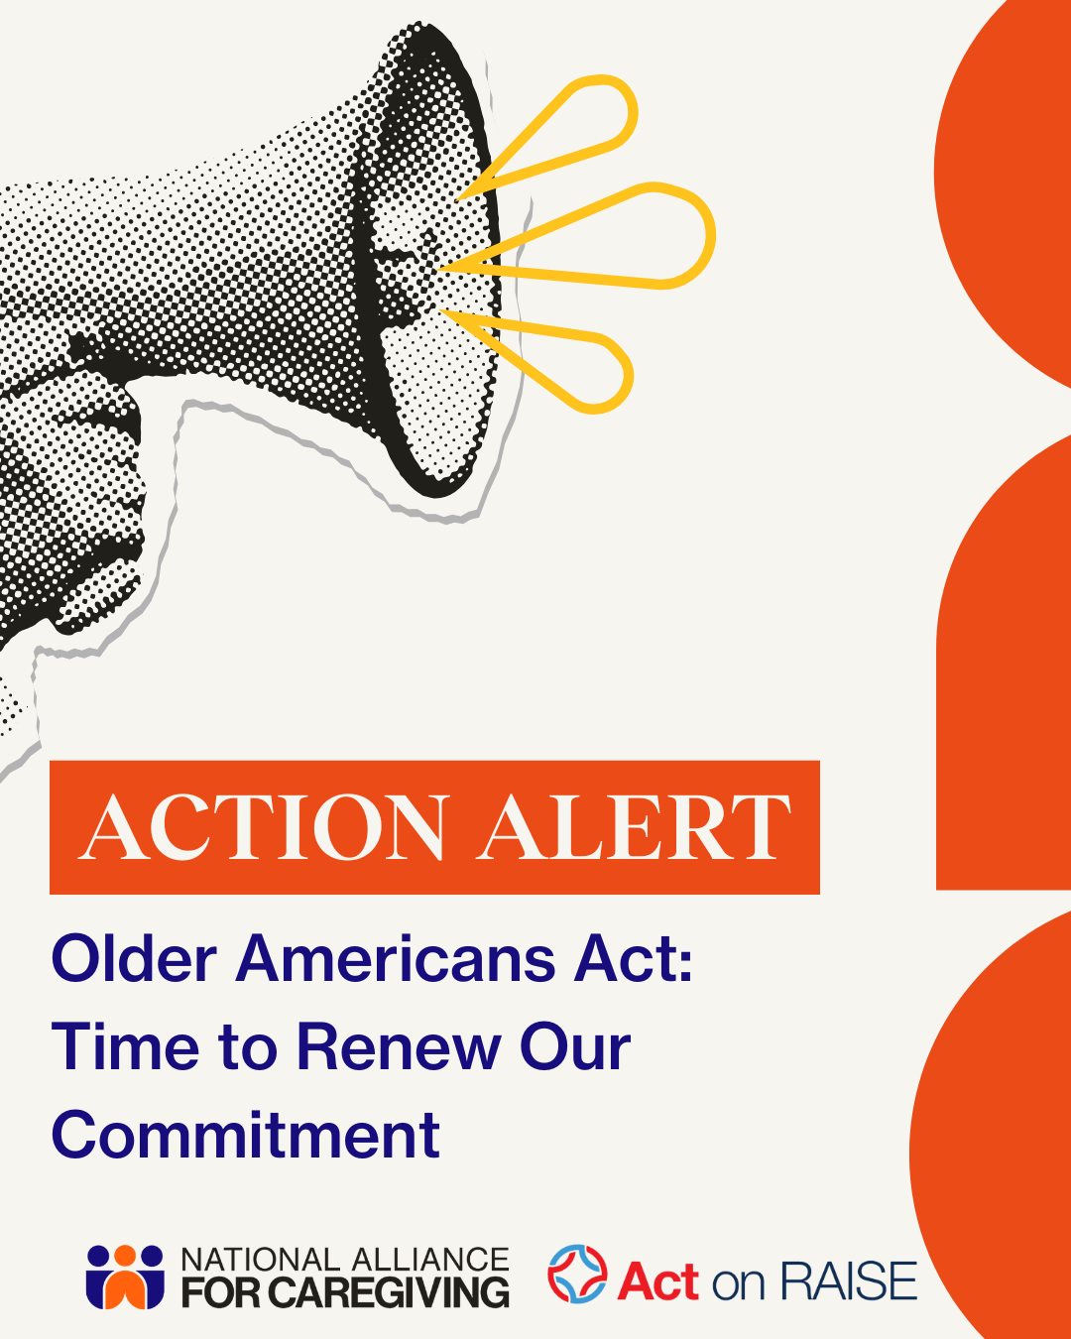 | 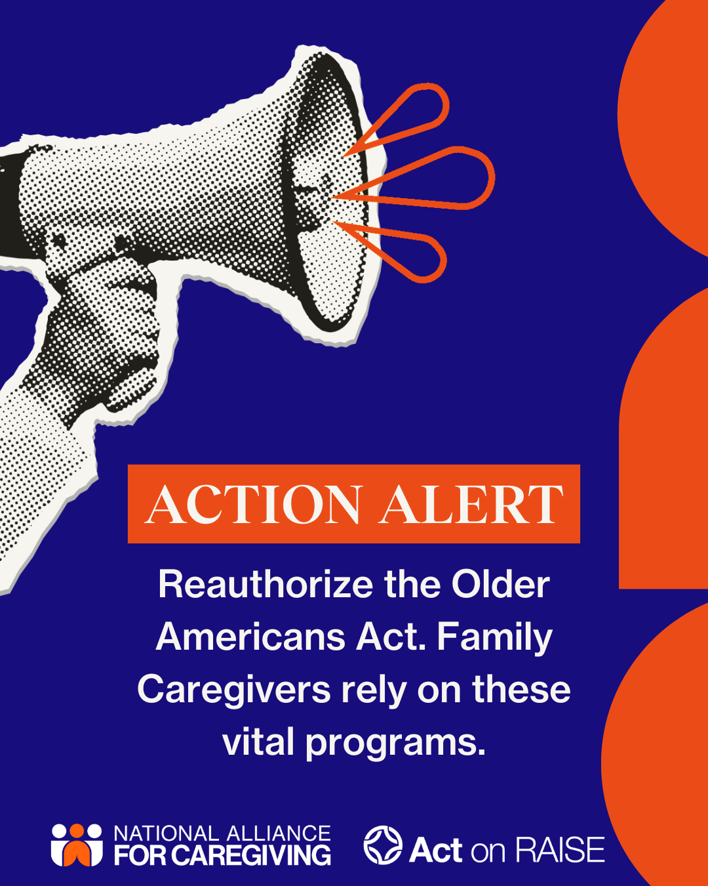

Sample Posts
Twitter (X)

Post 1:
🚨 The #OlderAmericansAct has expired leaving 63M+ family caregivers & older adults in limbo.
10k Americans turn 65 daily. Congress must act now to #ReauthorizeOAA because #CareCantWait!
#ActNow📝: https://bit.ly/4mS5uLo
#OAAReauth #OAA #SupportFamilyCaregivers

Post 2:
For nearly 60 years, the #OlderAmericansAct has helped seniors age with dignity & supported their caregivers.
🚨Now it's expired.🚨10k Americans turn 65 daily. #CareCantWait
#ActToday ✏️to urge Congress to pass #ReauthorizeOAA now: https://bit.ly/4mS5uLo

LinkedIn/ Facebook/ Instagram
🚨 For nearly 60 years, the Older Americans Act (OAA) has ensured older adults can age with dignity while supporting the 63 million family caregivers who make it possible.
But OAA authorization expired in 2024. Without action, essential services like meals on wheels, transportation, respite care, and elder justice protections are at risk.
⏳ Every day, 10,000 Americans turn 65. The need is growing, but caregivers and older adults remain in limbo.
Congress must act now to reauthorize the OAA to protect older adults from isolation and giving family caregivers the support they need and deserve.
#TakeActionNOW📝: https://caregiving.quorum.us/campaign/OAA2025-2030/
#ReauthorizeOAA #OAA #OlderAmericansAct #FamilyCaregivers #ActNow #Caregiving #SupportFamilyCaregivers

Template Letter to the Editor

[Your Name]
[Your City, State]
[Date]

To the Editor:

For nearly 60 years, the Older Americans Act (OAA) has been the cornerstone of our nation’s commitment to helping older adults age with dignity and to supporting the 63 million family caregivers who make that possible. Through meals, transportation, respite care, counseling, and elder justice protections, these OAA programs serve XX lives in our City, State/touches millions of American lives each year.

Today, the OAA stands at a crossroads. Authorization expired in 2024, and while programs are still funded, they lack the policy updates, funding increases and certainty that come with reauthorization. On June 18, the Older Americans Act Reauthorization Act of 2025 (S. 2120) was introduced in the U.S. Senate with bipartisan support. The bill extends OAA programs through 2030, strengthens caregiver services, and invests in the direct care workforce. Yet the House of Representatives has not advanced a companion bill, leaving older adults and caregivers in limbo.

Every day, 10,000 Americans turn 65 and they need support. With 63 million adults serving as family caregivers today, the urgency is clear. Without OAA reauthorization, older adults risk losing access to services that prevent isolation and institutionalization, and caregivers risk burnout.

Congress must act now. Reauthorizing the OAA ensures that adults can age with dignity and caregivers have the support they need.

Sincerely,
[Your Name]

