

ABOUT THIS TOOLKIT
The National Alliance for Caregiving (NAC), in support of the Act on RAISE Campaign, created this toolkit as a resource to help advocates, caregivers, and partner organizations explain the role of Medicaid in supporting family caregivers. With Medicaid at risk, it is critical to mobilize to raise awareness of the value of Medicaid and to advocate protecting essential Medicaid programs such as home- and community-based services/consumer- directed care, respite care, and other crucial resources and supports for family caregivers. We are hopeful the resources in this toolkit will help with your advocacy around the urgent need to protect Medicaid from devastating cuts and changes in policy that negatively impact family caregivers.

In this toolkit, you’ll find:
- Policy Brief: The Role of Medicaid in Supporting Family Caregivers
- Sample social media posts and branded and non-branded graphics
- Key talking points on Medicaid’s role in supporting caregivers
- Medicaid Factsheets and Infographics
- Resources and reports with credible data to help tell the story of impact
Together, we can strengthen the voices of family caregivers across the U.S. to ensure policymakers understand the critical role Medicaid plays in sustaining families and communities.

If you have any questions, please feel free to reach out to Davisha Davis at Davisha@caregiving.org.
Policy Brief: The Role of Medicaid
in Supporting Family Caregivers

While the federal government offers some assistance through programs like the National Family Caregiver Support Program, the Lifespan Respite Care Program, and Veterans Affairs Caregiver Programs, these fractured initiatives cannot meet the growing needs of millions of family caregivers.

Medicaid has emerged as the nation’s primary source of support for these caregivers, making it possible for many Americans to receive care in their homes rather than in costly nursing facilities. As the largest payer for long-term services and supports, Medicaid serves approximately 4.5 million people through home-and-community-based services (HCBS). Unlike Medicare, which typically does not cover these services, Medicaid provides both direct financial support to family caregivers and critical supplemental services such as respite care, training, and counseling – all of which help families avoid or delay institutional care.

Download the Policy Brief: The Role of Medicaid in Supporting Family Caregivers

Sample Social Posts and Graphics

📢 Take Action Today!
Medicaid serves as a vital lifeline supporting family caregivers nationwide. Investments in Medicaid are investments in our healthcare system and economy. We cannot afford to undermine the systems that support family caregivers, whose contributions are essential for the well-being of millions of Americans and provide substantial economic value.

Contact Congress today and tell them to protect Medicaid from drastic cuts and harmful policy changes. and tell them to protect Medicaid from drastic cuts and harmful policy changes.

#protectmedicaid #familycaregivers

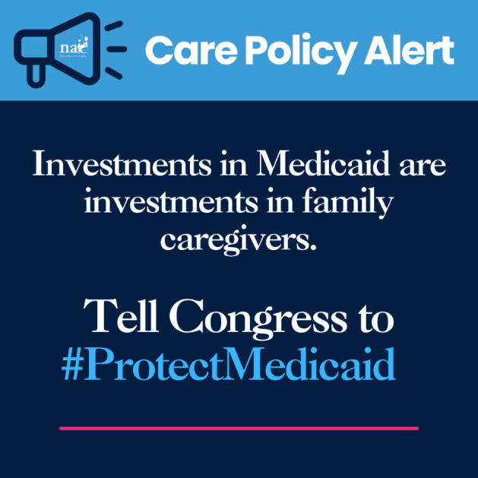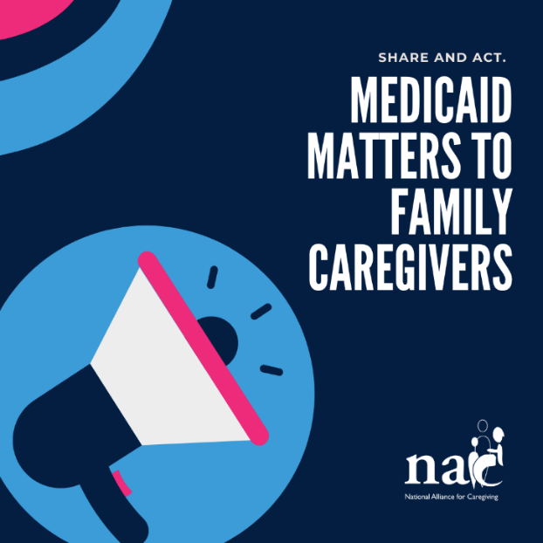

Social Media: Graphic #1
Family caregivers are the backbone of our nation’s long-term care system, and Medicaid serves as a vital lifeline supporting family caregivers nationwide. We cannot afford to undermine the systems that support family caregivers, whose contributions are essential for the well-being of millions of Americans and provide substantial economic value.

Together, we must act to protect Medicaid from drastic cuts and harmful policy changes.

#protectmedicaid #familycaregivers

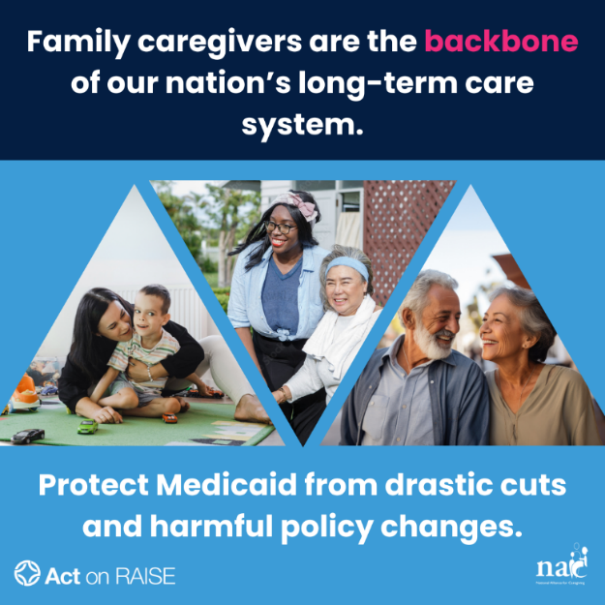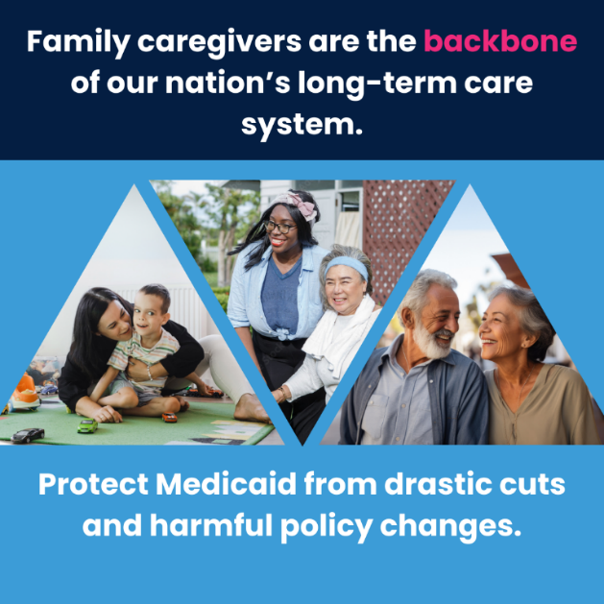

Social Media: Graphic #2
Did you know that family caregivers provide more than $600 billion to our nation’s economy? Caregiving is essential yet unrecognized work that saves the healthcare system billions by preventing costly institutional care. Together, we must act to protect Medicaid from drastic cuts and harmful policy changes.

#protectmedicaid #familycaregivers

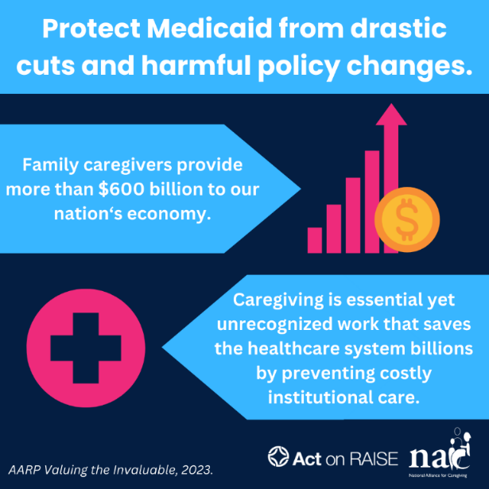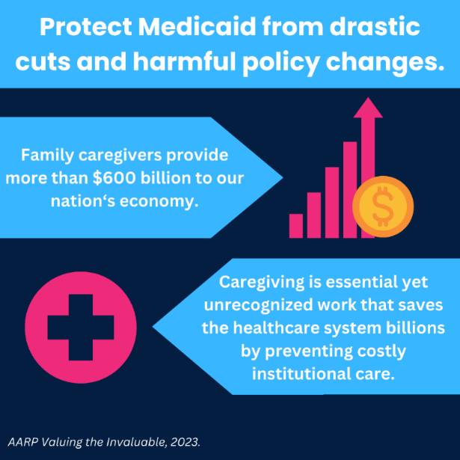

Social Media: Graphic #3
Family caregivers provide complex care to aging, disability, patients with chronic diseases and conditions. It is an immense responsibility and a full-time job.

Did you know:
12% of adults receiving Medicaid are not working due to their family caregiving responsibilities.
11 million family caregivers provide 41+ hours of care a week

Together, we must act to protect Medicaid from drastic cuts and harmful policy changes such as unrealistic work requirements.

#protectmedicaid #familycaregivers

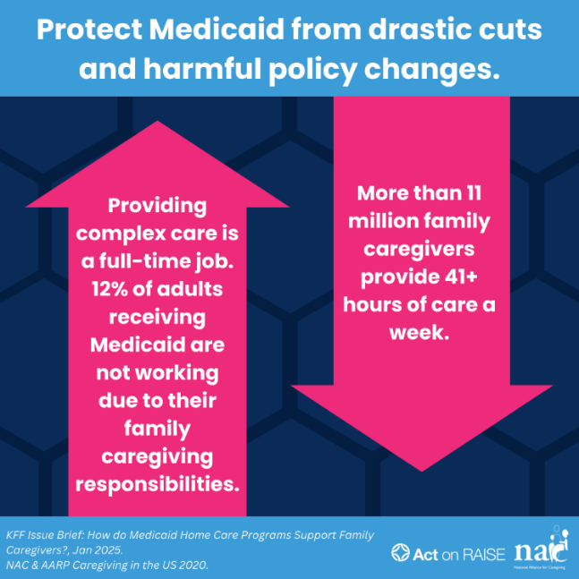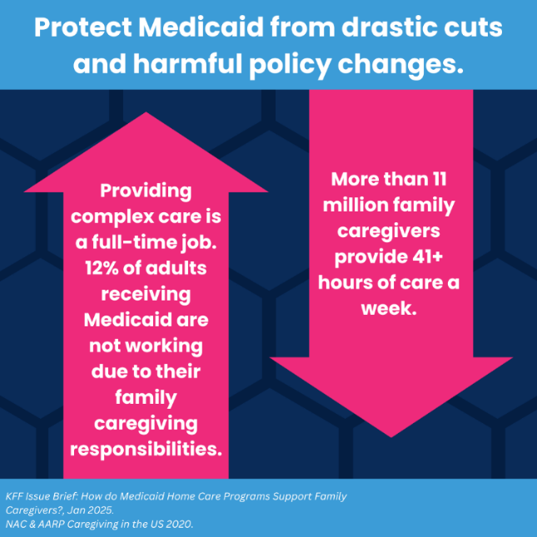

Download all graphics here: https://drive.google.com/drive/folders/1bgV0yXwRWQ94YSZ8h7VK2DNqKsN1GZrm?usp=drive_link

Key Talking Points

The Role of Medicaid in Supporting Family Caregivers

- For those with the greatest need, Medicaid is the backbone of America’s long-term care system and the most comprehensive program to support family caregivers in low-income families. Medicaid serves approximately 4.5 million people through home-and-community-based services (HCBS).

- Family caregivers are essential partners in delivering complex care, helping millions of Americans remain in their homes and communities while reducing costs for the healthcare system.

- Medicaid provides both direct financial support to family caregivers and critical supplemental services such as respite care, training, and counseling - all of which help families avoid or delay institutional care.

Medicaid's self-directed care programs allow beneficiaries to choose and pay family caregivers, providing high-quality care at lower costs while addressing critical healthcare worker shortages.

- The 2022 National Strategy to Support Family Caregivers – created by a law signed by President Donald Trump in 2018 - identifies Medicaid as a critical program for expanding access to respite care, providing direct payment to family caregivers, and offering essential training and support services.

The Potential Impacts of Medicaid Work Requirements

- Family caregivers who qualify for Medicaid often face a challenging situation when balancing their caregiving responsibilities with complex and burdensome work requirements. This situation can jeopardize their access to health coverage, essential for maintaining their well-being and ability to provide care.

- Family caregivers already experience worse health outcomes than non-caregivers, and losing Medicaid coverage would further compromise their health and ability to provide care for others.

- Data from 2023 shows that while approximately two-thirds of Medicaid enrollees between ages 19-64 maintained employment, 12% were unable to work due to caregiving responsibilities.

- Medicaid work requirements can force family caregivers to choose between maintaining their health coverage and providing essential care, as many must reduce work hours or leave jobs to care for loved ones.

- As policymakers consider changes to the Medicaid programs, including work requirements and other eligibility restrictions, it is crucial to understand how these policies affect family caregivers' ability to maintain their own health and continue providing care for the people in their lives.

Fact Sheets & Infographics

Medicaid Home and Community Based Services (Download graphics using link)
Factsheet
Infographic
Social Graphic 1
Social Graphic 2

Respite Care Programs (Download graphics using link)
Factsheet
Social Graphic 1
Social Graphic 2

Resources & Reports

How do Medicaid Home Care Programs Support Family Caregivers? KFF, January 2025.

Emerging Respite Care Strategies in Medicaid Home and Community-Based Services Waivers for Older Adults, Adults with Physical Disabilities, and their Family Caregivers. NASHP, May 2023.

Work Requirements Would Cut Medicaid for Older Adults. Justice in Aging, February 2025.

Valuing the Invaluable 2023 Update: Strengthening Supports for Family Caregivers. AARP, 2023.

Hard choices ahead for states on Medicaid. Acios, January 2025.

Eliminating the Medicaid Expansion Federal Match Rate: State-by-State Estimates. KFF, February 2025.

See How Medicaid is Helping People in Your State. Modern Medicaid Alliance.

Medicaid and Its Role for Older Adults: 51 State Fact Sheets. AARP Public Policy Institute, April 2025.

